Family Fitness Night

**Thursday, April 10th at 6:00 – 7:30 pm**

**Alice Deal Middle School**

**School Gymnasium**

3815 Fort Drive NW, Washington, DC 20016

Bring your family for a night of **FUN** & **FITNESS**.

Fitness testing, CrossFit kids drills, nutritious food tasting, and more...

**FUN FOR THE ENTIRE FAMILY!**

For additional info, please contact Neal Downing at neal.downing@dc.gov

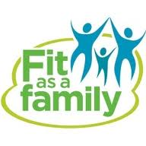­

**WHO IS THE FITTEST FAMILY ON THE PLANET??**