PARENTS YOU ARE CORDIALLY INVITED TO ATTEND…

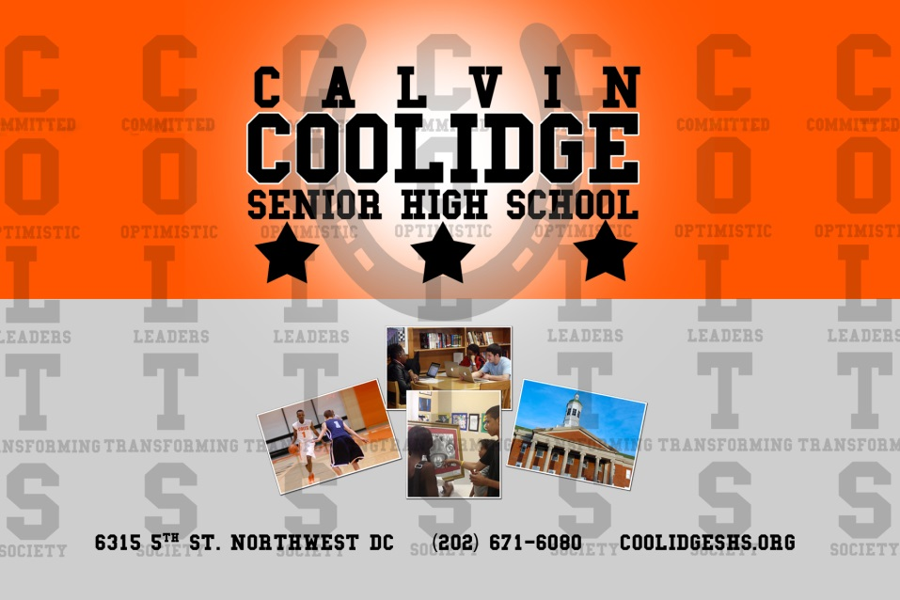

Calvin Coolidge Senior High School’s
Middle School Open House

December 15, 2014 5:00pm -7:00pm
- Coolidge Colt Panel
- Mini Lesson Classroom Rotation
- Receive 2 Tickets to the Basketball Game with parent
(same night *Coolidge vs. Phelps)

For more information: contact Sereta Moore 202-270-2940 or Sereta.moore@dc.gov

