Fricatives, Clicks and Implosives: In the Phonetics Lab

I sat with 20 other students in the phonetics lab, trying desperately to make the sounds the professor was demonstrating. To put it mildly, my articulators—as I learned to call my tongue, lip, teeth and uvula—did not cooperate. At least, not at first.

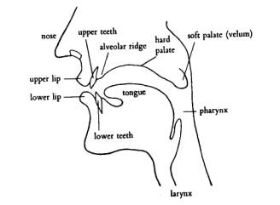

One of the first things we learned is that human infants can make all the sounds necessary to speak any human language. These sounds are called phonemes, the smallest units of sound distinguishable within units of meaning. During the first months of life, babies imitate the phonemes they hear, and the rest of the phonemes gradually fade.

As we grow into adulthood, it takes special training not just to make sounds that aren’t included in our native language but even to hear them. Foreign accents are created—in any language—when the learned language contains sounds the native language lacks.

Our goal in the phonetics lab was to relearn how to hear and make all the sounds used in human languages. And it was great fun!

The first day, we spent more time laughing at each other than anything else, but the work was complicated. We learned how to form voiced fricatives like *z* and plosives like *p* in many different forms.

It took time to remember where to place the tip of the tongue, how the lips interacted, whether the breath was taken in or exhaled, if the vocal chords were activated. Vowel sounds could be front or back; high, med, or low; and any combination thereof.

When we understood our own sounds, we were introduced to implosives and ejectives, trills, flaps and the deep pharyngeal consonants. Our professor amazed us with a string of Zulu words containing clicks and pops.

It was particularly fun outside of class to put together a string of sounds and nod seriously as if carrying on a conversation. We were learning only isolated sounds, not a language. But the people we impressed on campus didn’t know that...

We were also expected to transcribe those sounds accurately using the International Phonetic Alphabet, partially shown below. That was very much like learning a new language: listen, dissect the sound, and use the correct symbol.



I have a good ear, but that area of linguistics didn’t interest me, and when my professor offered an opportunity to accompany her as a research assistant, I politely declined. My linguist degree was to be a first step into the world of translation and interpreting.

*Images courtesy of Wikipedia.*

Next month: Phonetics in Leningrad