North Perth Merchants
The Perth County Visitors Association (PCVA) is happy to offer your group the opportunity to joint market North Perth as a whole in the Perth County Tour and Travel Guide.
The PCVA is offering each merchant the opportunity to buy into the Tour and Travel Guide and become a marketing partner with the PCVA for 2013 for $105.00. We are able to offer this deep discount because of the generosity of the North Perth Chamber of Commerce, Listowel BIA and Downtown Merchants Association.
What is included for the $105.00?
A Photo Highlight listing in the guide, which includes a picture of your business and listing in the back of the guide. Example below:
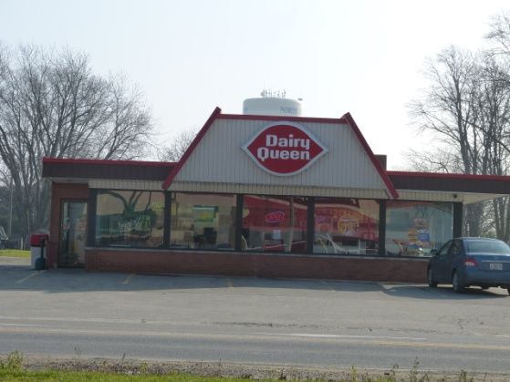
Dairy Queen
160 Mitchell Rd. S.,
Listowel On
519-291-1401
Come in and try one of our combo deals with a choice of burger, chicken or sandwich. To save a few dollars order from our Sweet Deals menu, with over 20,000 meal combinations. If you want something sweet choose from one of our 20+ blizzard soft serve blends or try an Orange Julius smoothie in store now. Winter- 11AM - 8PM Summer- 11AM - 10PM

- A micro site for your business on our website and hotlinks to your own website.

- Our website is very user friendly and have well over 5,000,000 hits per year. We also have a very active event calendar for all of Perth County.

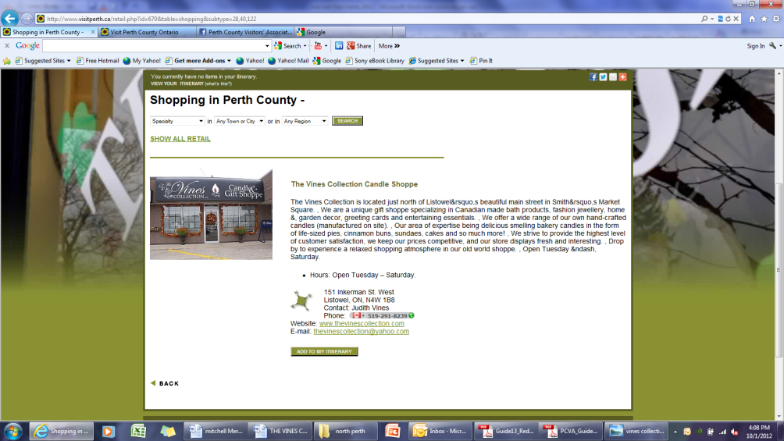

To mention a few of the opportunities of being a marketing partner with the PCVA are the Perth County Welcome Centre and Artisan Market, Motorcycle Map/Forbidden Ride Event , All Female Wicked Ride, Buy Local Buy Fresh Map, Savour Stratford Perth County Culinary Event, Shakespeare to the Shoreline program, Ontario Motor coach Association, and Arts and Culture Initiative.
There are many other benefits to be a member with the PCVA. If you would like to see the membership package and what you will receive it can be found at http://www.visitperth.ca/partnership.html
If you are interested in this offer please email me at info@visitperth.ca or call me at 519-603-3724.
Or you can go to: http://www.visitperth.ca/partner-form.html
Fill in your form online to become a partner and pay for through PayPal or call the Welcome Centre with your credit card info or mail cheque to: Po Box 340, Shakespeare, ON N0B 2P0
We look forward to working with you this coming year!
Thank You
Cathy Bieman
519-603-3724-work
519-801-5320- cell
visitperth@cyg.net
www.visitperth.ca

