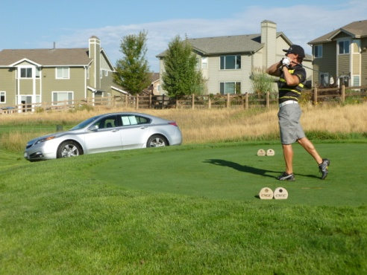
2014 - COAL MINER GOLF CLASSIC
Friday, September 5

_____$5,000 Presenting Sponsor
• Business Banner on Chamber Event Page for 2 weeks (end Aug/first Sept)
• Full Page Advertising in Chamber E- Newsletter (September Issue) • Business name and logo on goody bags • Opportunity to talk at luncheon • Market business at select hole • Business banner displayed at course (Sponsor provides Banner) • Tournament play for two-foursomes • Business name on 6 tees box signs • Business name on 6 carts
• Business name and logo on luncheon program • Business name and logo on luncheon Table Tents
• Listed as Presenting Sponsor
_____$2,000 Gold
• Half Page Advertising in Chamber E-Newsletter (September Issue) • Market business at select hole • Tournament play for one-foursome
• Business name on 3 tee box signs • Business name on 3 carts
• Business name on luncheon program • Business name on luncheon Table Tents
_____ $1, 000 Silver
• Market business at select hole
• Tournament play for one-foursome
• Business name on 2 tee box Signs
• Business name on 2 carts • Business name on luncheon program • Business name on luncheon Table Tents • Quarter Page Advertising in Chamber E-Newsletter (September .Issue)
_____$175 Bronze
• Business name on 2 Tee box Signs • Business name on 2 carts • Business name on luncheon program
_____$125 Copper
• Business name on 1 Tee box Sign
• Business name on 2 carts • Business name on luncheon program
_____$75 Brass
• Business name on 1 Cart Sign
• Business name on luncheon program

