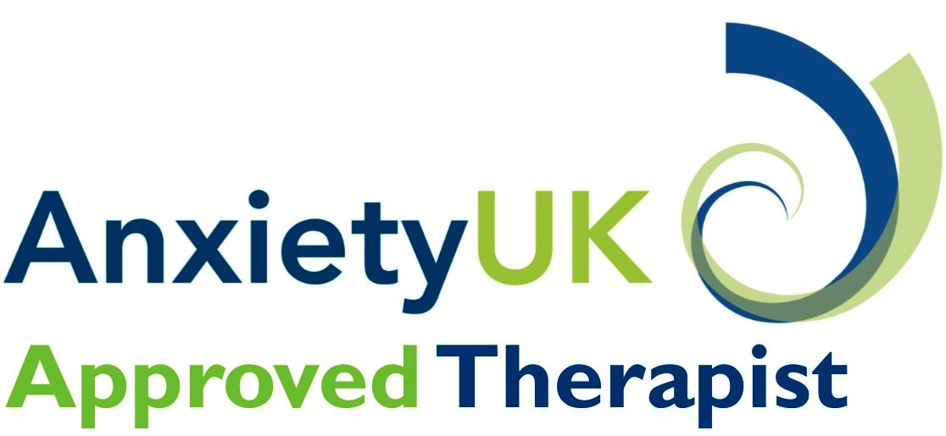

**What is the Anxiety UK approved therapist scheme?**

**Anxiety UK** is a registered charity, established in 1970 that provides a range of services and support for those affected by anxiety disorders and has been working for more than 40 years to ensure individuals can have fast access to affordable, high quality therapy.

We have worked alongside many Clinical Hypnotherapists, CBT therapists and Counsellors and we were ‘improving access to psychological therapy’ long before the government launched its IAPT initiative.

Demand for our services has grown during a time of economic uncertainty for many. People need to be able to obtain fast access to treatment in adversity.

As a qualified therapist, or someone working towards accreditation or in training, Anxiety UK can offer you the opportunity to be part of a scheme where you will gain invaluable experience of working with clients presenting with a range of anxiety disorders from conditions such as agoraphobia, social phobia, Obsessive Compulsive Disorder (OCD) through to specific phobias such as needle phobia, spider phobia etc.

**Benefits of being an Anxiety UK Approved Therapist – what’s in it for you!**

|  |  |
| --- | --- |
| **Available from Anxiety UK** | **Anxiety UK**  **Approved therapist** |
| Unique dedicated Anxiety UK approved therapist logo for all your literature and online marketing materials | ✓ |
| Payment for therapy for our members range from £15 -£50 (£12 to £40 per session for phone or web cam support) for traditional therapy services and £50 per session for FAST (see below) | ✓ |
| The opportunity to offer support to **non-members** via our FAST scheme, a quick and alternative method to access therapy support from Anxiety UK approved therapists at the rate of £50 per session | ✓ |
| Access to AUK membership package at reduced rate of £20 annually (normal rate £30) with all the benefits of membership including the quarterly magazine Anxious Times | ✓ |
| Access to various useful practitioner resources including risk assessment flow charts, safeguarding protocol, advice and good practices. | ✓ |
| Opportunities for training & development supplemented by CPD support and dedicated Anxiety UK therapist conference (inaugural event planned for Autumn 2014) | ✓ |
| Access to a dedicated therapist area on Anxiety UK’s web site with a range of downloadable resources to support your practice and networking opportunities with your peers to share best practice. | ✓ |
| Our offer caters for trainee, newly qualified and fully accredited therapists providing the opportunity to work towards accreditation or client hours with a diverse range of clients from the mild to more complex and for those new to private practice, the Anxiety UK therapy placement allows you to gain the skills needed to become independent, whilst still under the umbrella of a national charity. | ✓ |
| Access to informal line management supervision on request and regular communication from AUK including regular Services E-news bulletins, sharing of case studies & best practice examples | ✓ |
| Regular communication from the AUK and sharing of case studies & best practice information. | ✓ |
| Links to our clinical advisory panel, eminent experts in the field of anxiety who support and advise the work of AUK and its team of therapists | ✓ |
| Professional access to AUK clients if you wish to undertake research into any field of anxiety in support your work and training as a therapist | ✓ |
| The option to be an expert in a particular field, e.g. the provision of therapy for clients from a specific BME community | ✓ |

**How do I become an AUK approved therapist?**

Complete the online application form via our website (see below), pay £25 processing fee and submit details of two referees

Anxiety UK source references from your named referees

(this normally takes 2-3 weeks)

Once references are received we will arrange a telephone interview with you

All relevant paperwork completed, returned to Anxiety UK and outcome of DBS check satisfactory then you will be added to our database ready to receive referrals

Subject to a satisfactory

interview outcome

**How we set therapy rates**

Payments will range between £12 and £40 for phone and web cam support and £15 and £50 per session for face to face therapy. Please note: Anxiety UK sets the client rate and depending on the type of therapy will take either two (clinical hypnotherapy) or three (CBT & Counselling) payments up front. This is to contribute to the running of the therapy service, something we currently do not receive any external funding for.

**For more information**

Full details on how to apply and the qualification criteria can be found here - <http://www.anxietyuk.org.uk/support-us/get-involved/become-an-anxiety-uk-therapist> - but if you have any specific questions please don’t hesitate to contact me. Please do bear in mind, though, that we are unable to guarantee any degree of regular referrals or to forecast the volume of them at any given time.

You can find the application process here <http://www.anxietyuk.org.uk/products/category/therapist-application>